https://www.ioi2021.com/
Briefing Document

Sign in to the Virtual Conference Portal with your email address and Pin
  - The link to the Virtual Conference Portal and your Pin will be emailed to you prior to the conference.
  - Please open the virtual platform via Google Chrome (Explorer is not supported)

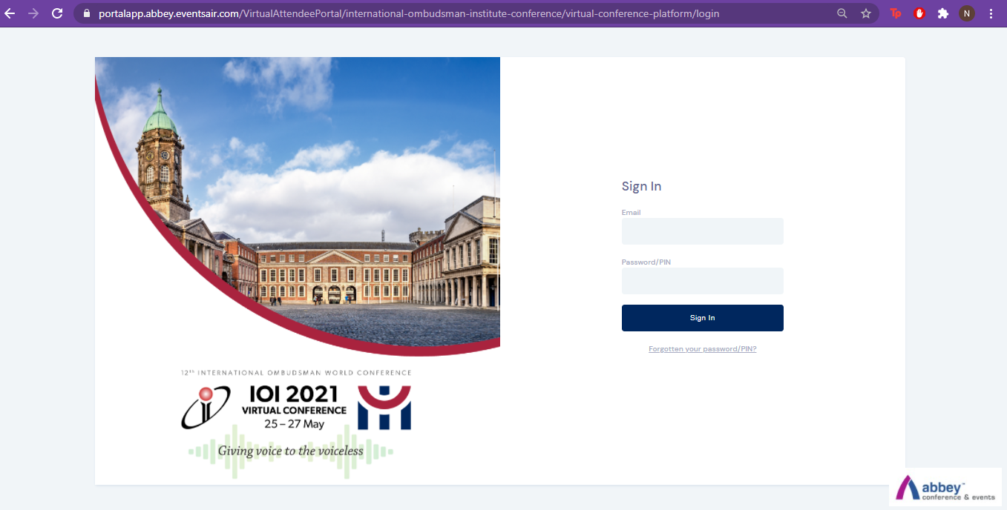

Allow access to your camera and microphone
  - You will be prompted to allow access to your microphone & camera when you sign in:

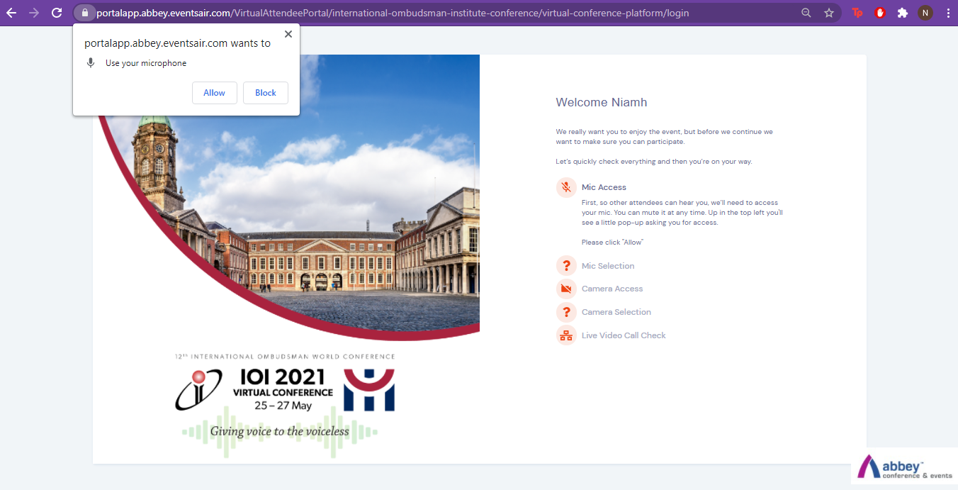

  - If your camera and microphone are not working, please click on your profile in the top right hand corner, then View Settings and scroll to the Media Settings section and select your camera and microphone. Please make sure to scroll back to the top and click on update.

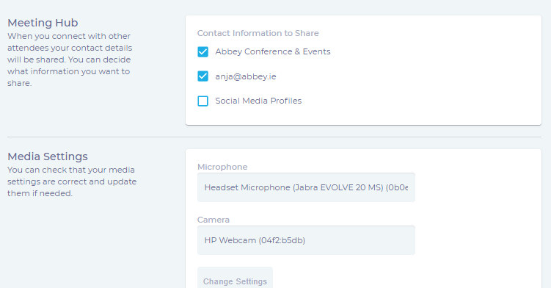

When signed in you will be brought directly to your timeline. This is the days agenda and you can select which sessions you would like to attend by clicking on preview/join.

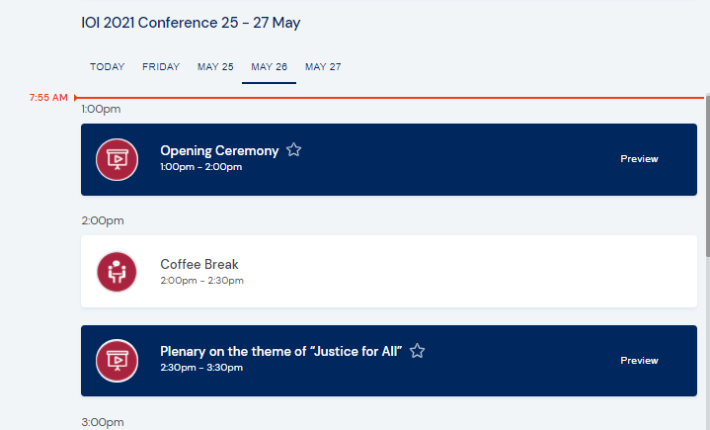

    - As a delegate you will see the below screen. On the right hand side you will be able to see a countdown timer to the next session, session information regarding the speakers in the session, ask questions through text, have a conversation with all delegates through the discussion forum and take notes from the session which you can later download. Please note all attendees can see what is written in the discussion forum. Private discussion is best facilitated by using the meeting hub.

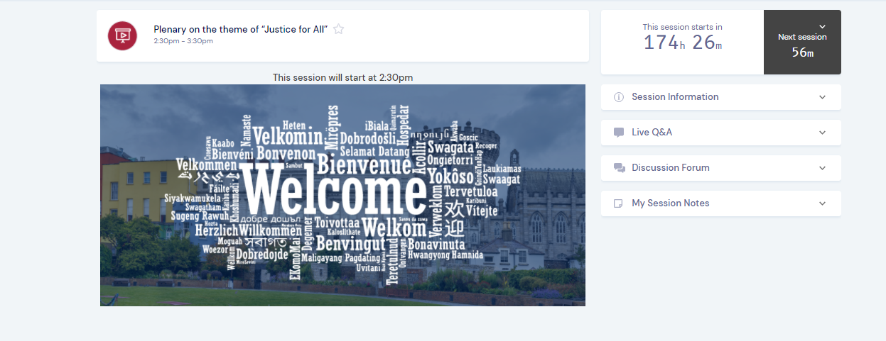

End of the session
- When the session ends please click back to timeline arrow on the top left hand corner to return to the timeline. Please do not click the back button in your browser as this will log you out.
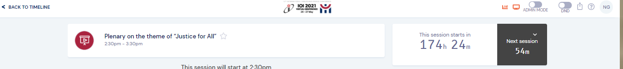

If you experience any problems
If during the session you experience any issues, please contact Live Support in the top right hand corner of the screen. Please note live support will be provided in English. If you request help through Spanish or French the support you receive will be translated through Google translate.

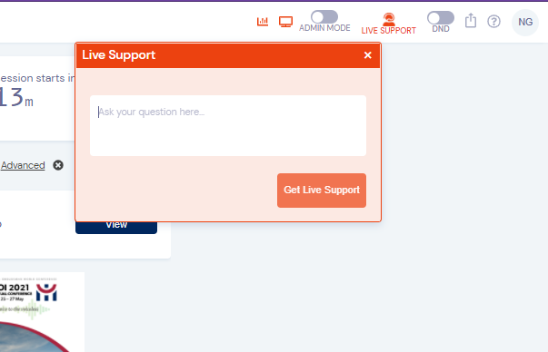

- If you have issues logging back into the Virtual Conference Portal, please email ioi2021@abbey.ie

