Translation Services Guidance Document (Mobile App)

Please note it is recommended that the app be installed in advance of the General Assembly and Conference.

- Download and install the Interprefy app from the app store.
Download: Apple iOS (iPhone)
Download: Android (Google Play)

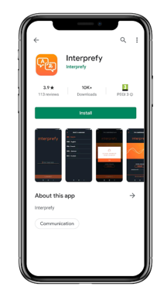

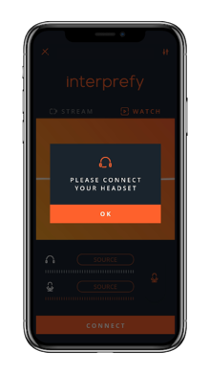
- Plug in your earphones or headset, click «ok».

- Enter the event token, click «connect». The token for the General Assembly is xxxx. The token may differ for the duration of the conference depending on the workshop you are in session. This information will be provided in the details of the session and on the website. If you are unsure of which token to use please get in contact with live support or email ioi2021@abbey.ie
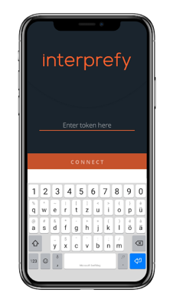

- Select your preferred audio language from the list available. (English, French, Spanish)
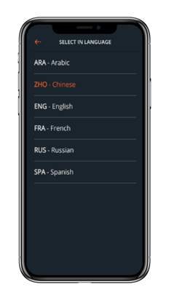

- Disconnect

When the session is finished, click «disconnect» to leave the session. You may need a different token for the next session depending on your session choice. Token information will be in each session and on the website.
